1. Create a student class using student properties and create and execute a method without a constructor.

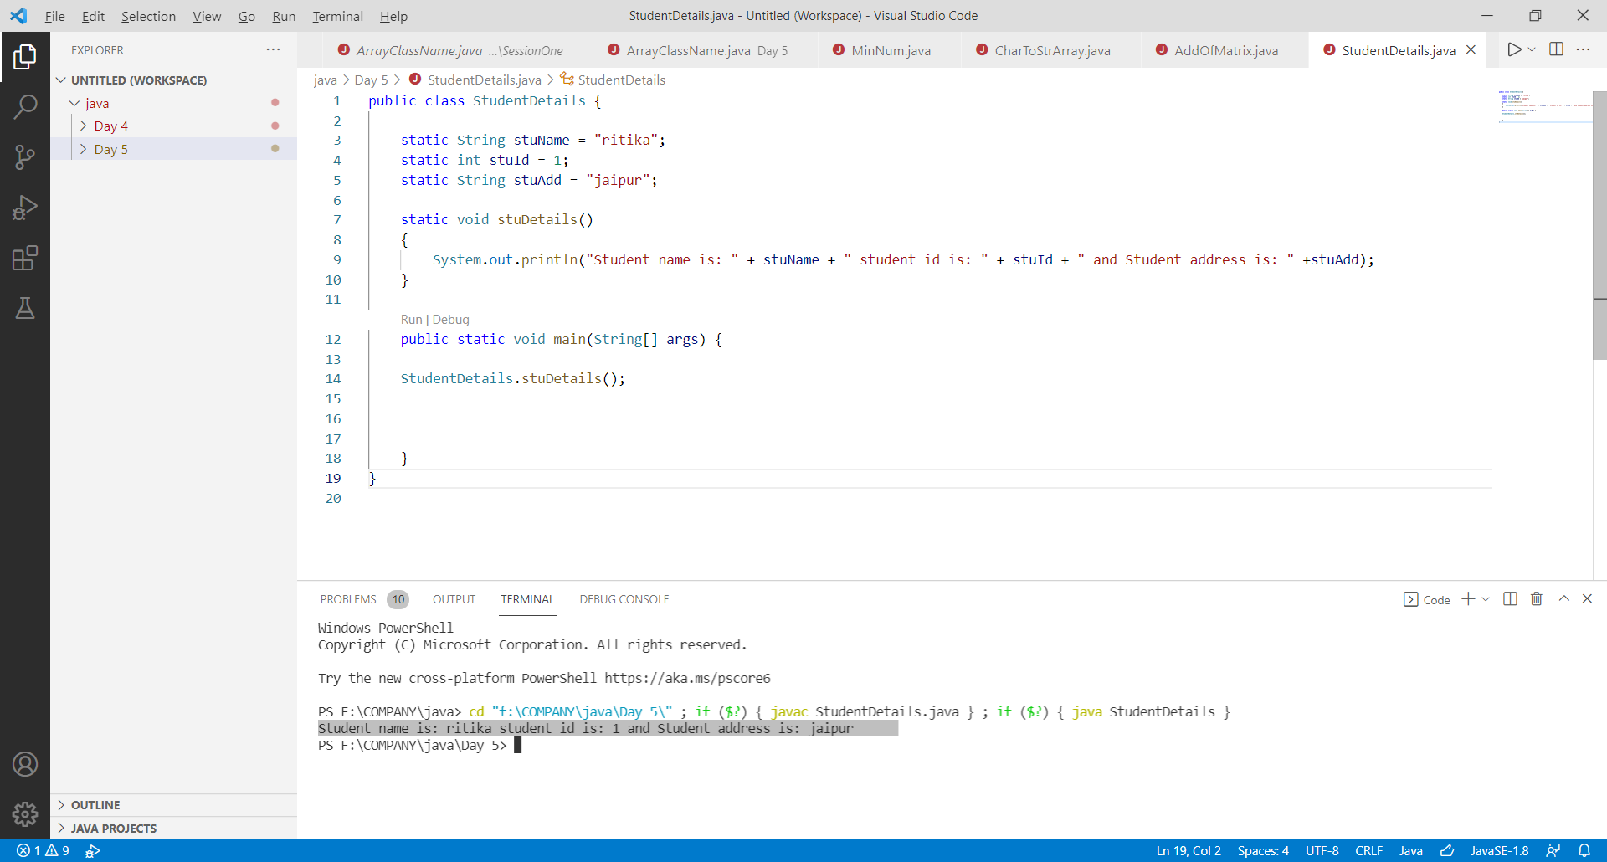

1. Create a Product class with constructor (observe the difference with or without constructor)

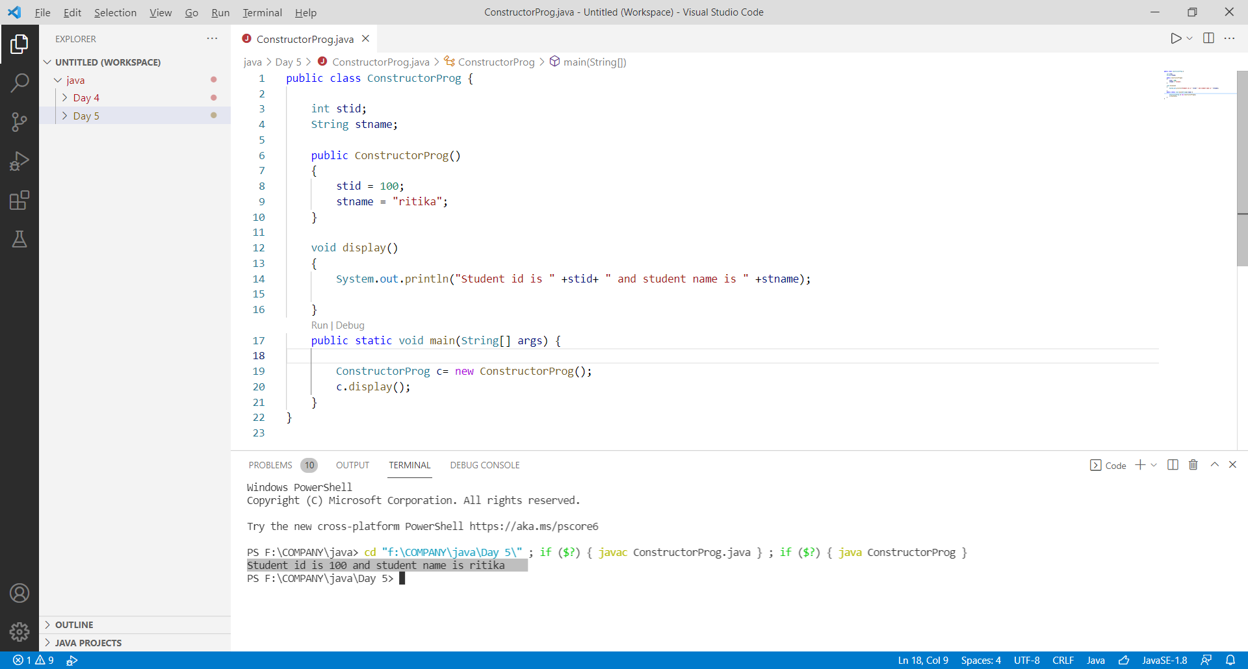

1. Create a Student class without parameters and with parameters by using constructor.

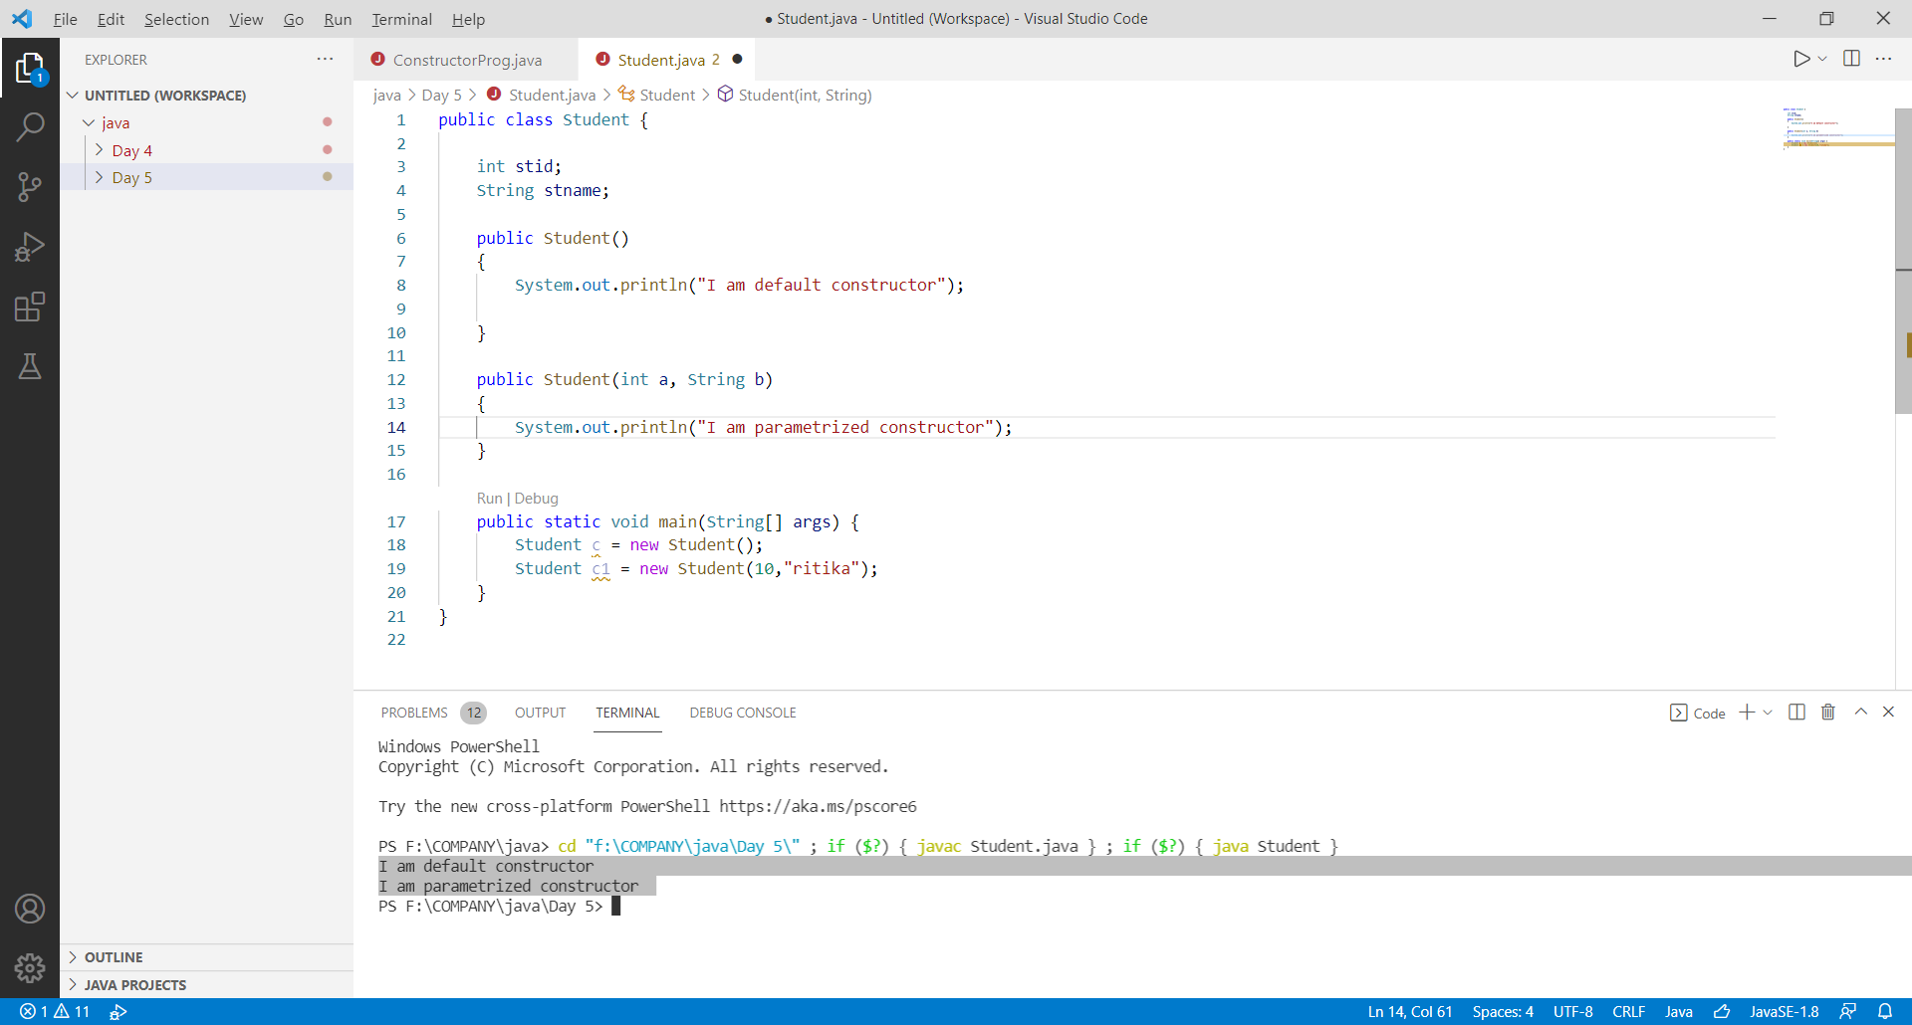

1. Create a Calculator class and create static methods with or without return type.

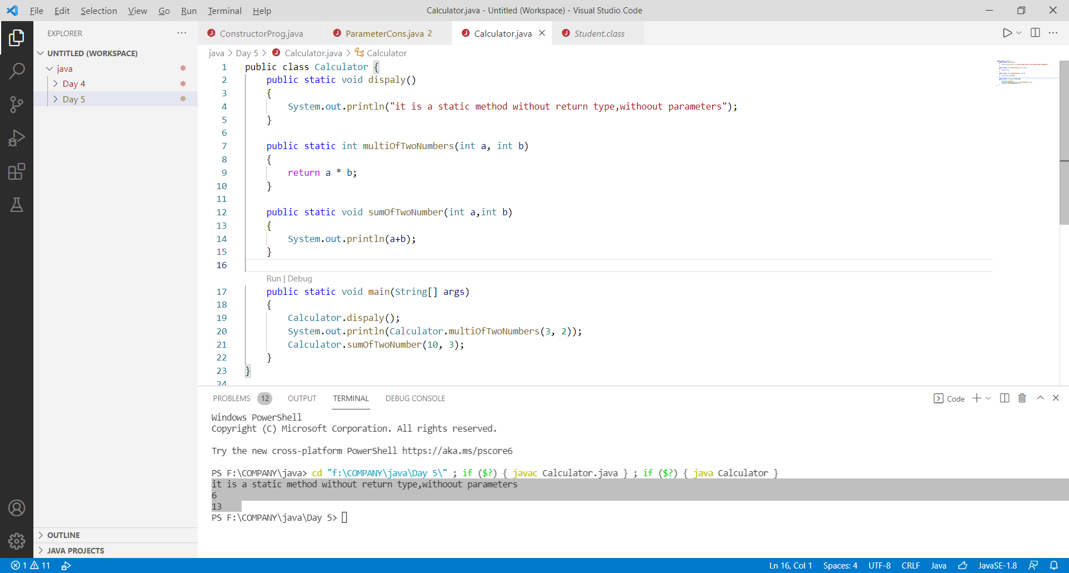

1. Create a Calculator class and create instance methods with or without return type.

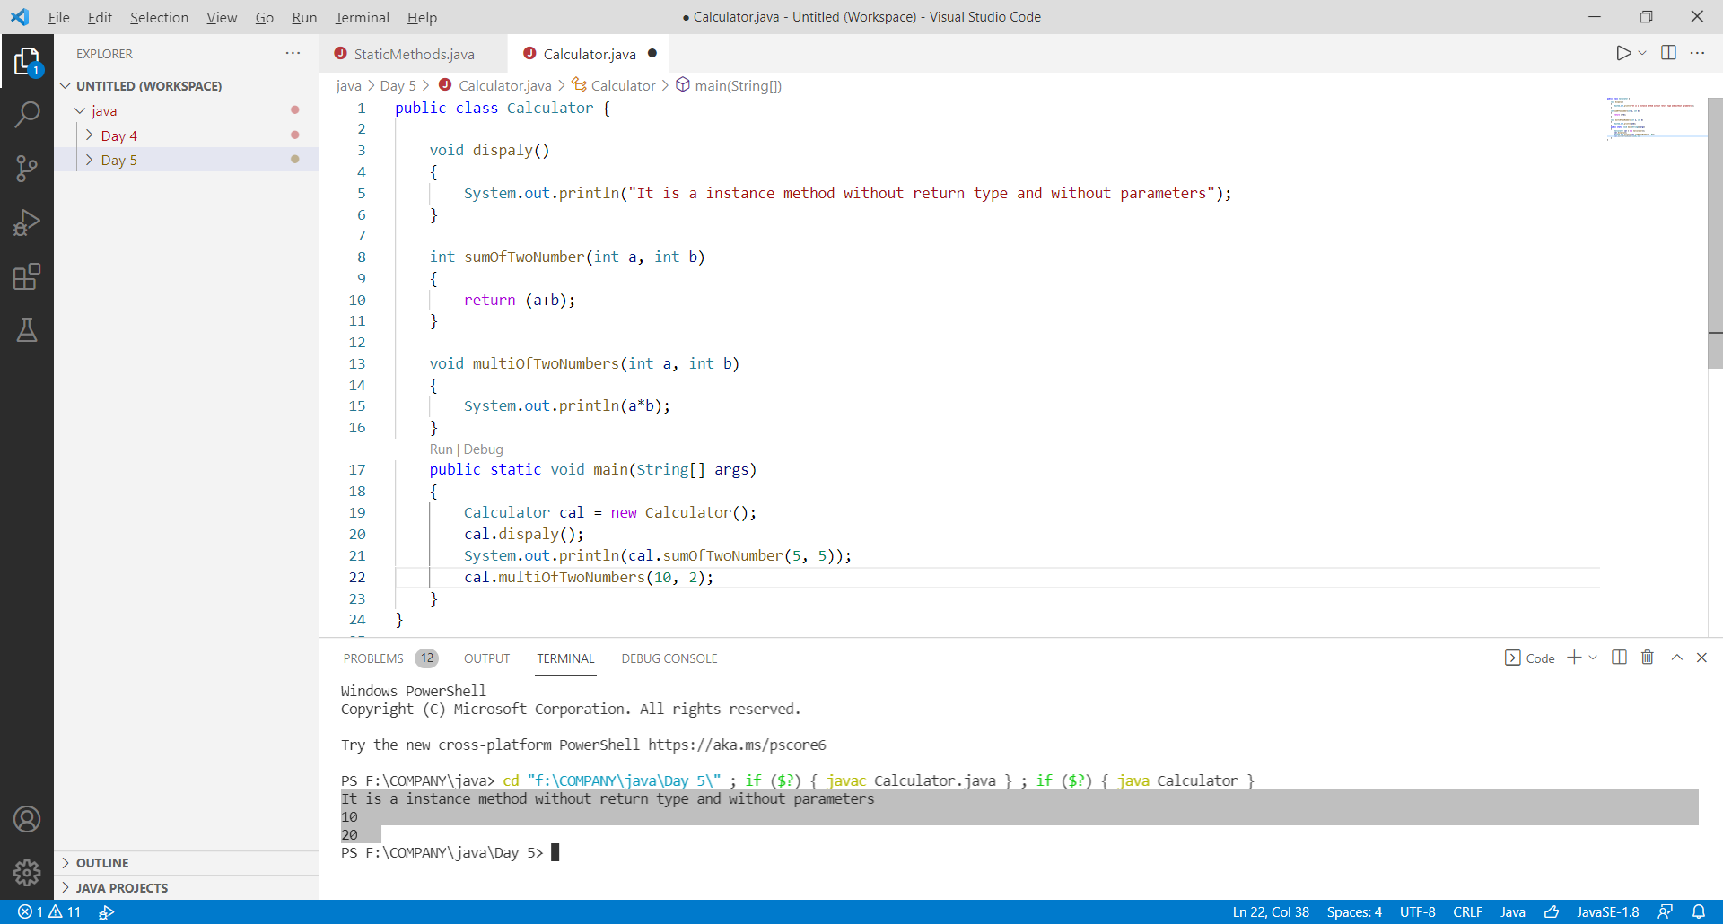

1. Create class Test print all the methods of String.

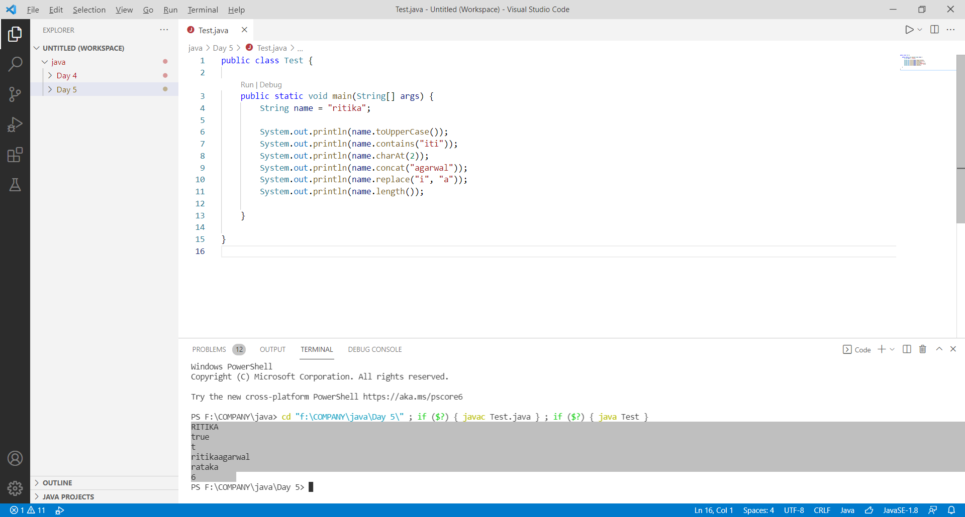

1. Create a class Add add two numbers by using Wrapper class.

